DBMS Lab Assignment

Submission by: AKSHAY JAIN

Registration Number: 17BCS002

**TOPIC ASSIGNED: INSURANCE COMPANY**

**Important Functions of Insurance Company:**

1. An Insurance company have multiple types of insurances like Life Insurance, Car Insurance, etc.
2. An (1) Insurance company have multiple (i.e. N) policies.
3. A (1) policy has (1) reimbursement payment (Insurance Company Pays).
4. A (1) policy can have multiple (N) Policy Holders.
5. A (1) customer can have multiple (N) Policies registered in their name.
6. A (1) customer have an (1) Agent.
7. An (1) agent have multiple (N) customers.
8. A (1) customer lives at a (1) particular address.
9. A (1) customer meets with (N) accidents.
10. An (1) agent works at a (1) particular location.

**Entities and its Attributes:**

* Insurance: Insurance Type, Insurance ID
* Policy: Policy Number, Issue Date, Term Cost, Amount Coverage, Policy Type, (Insurance ID)
* Payment: Transaction ID, Date of Payment, (Report ID)
* Customer: Customer ID, First Name, Last Name, Aadhar Number, Date of Birth, Driving License Number, Contact Details, (Pincode), (Agent ID), (Policy Number)
* Address: State, City, Pincode
* Agent: Agent ID, First Name, Last Name, User Name, Date of Birth, Aadhar Number, Contact Details, (Pincode)
* Accident: Date, Report ID, Police Report Document, Damage Cost, Fault, (Customer ID)

Note: Attributes inside Parantheses are Foreign Keys

**Relational Database Schema:**

* **INSURANCE:** (Insurance_Type: *STRING, NOT NULL, FOREIGN KEY*; Insurance_ID: *INTEGER, PRIMARY KEY, AUTO INCREMENT*)
* **POLICY:** (Policy_Number: *INTEGER, PRIMARY KEY, AUTO INCREMENT*; Issue_Date: *DATE, NOT NULL*; Term_Cost: *FLOAT, NOT NULL*; Amount_Coverage: *FLOAT, NOT NULL*; Policy_Type: *STRING, NOT NULL;* Insurance_ID: *INTEGER, FOREIGN KEY*)
* **PAYMENT:** (Transaction_ID: *INTEGER, PRIMARY KEY;* Date_of_Payment: *DATE, NOT NULL;* Payment_Amount: *FLOAT, NOT NULL;* Report_ID: *INTEGER, FOREIGN KEY*)
* **CUSTOMER:** (Customer_ID: *INTEGER, PRIMARY KEY, AUTO INCREMENT*; First_Name: *STRING, NOT NULL*; Last_Name: *STRING, NOT NULL*; Aadhar_Number: *STRING, UNIQUE, NOT NULL*; Date_of_Birth: *DATE, NOT NULL*; Driving_License_Number: *STRING, NOT NULL*; Contact_Details: *STRING, MULTIPLE VALUES, NOT NULL;* Pincode: *INTEGER, FOREIGN KEY;* Agent_ID: *INTEGER, FOREIGN KEY*; Policy_Number: *INTEGER, FOREIGN KEY*)
* **ADDRESS:** (State: *STRING, NOT NULL*; City: *STRING, NOT NULL*; Pincode: *INTEGER, PRIMARY KEY*)
* **AGENT:** (Agent_ID: *INTEGER, PRIMARY KEY, AUTO INCREMENT*; First_Name: *STRING, NOT NULL*; Last_Name: *STRING, NOT NULL*; User_Name: *STRING, NOT NULL, UNIQUE*; Aadhar_Number: *STRING, UNIQUE, NOT NULL*; Date_of_Birth: *DATE, NOT NULL*; Contact_Details: *STRING, MULTIPLE VALUES, NOT NULL;* Pincode: *INTEGER, FOREIGN KEY*)
* **ACCIDENT:** (Date: *DATE, NOT NULL*; Report_ID: *INTEGER, PRIMARY KEY, AUTO_INCREMENT*; Police_Report_Doc: *IMAGE, NOT NULL*; Damage_Cost: *FLOAT, NOT NULL*; Fault: *BOOLEAN, NOT NULL;* Customer_ID: *INTEGER, FOREIGN KEY*)

Note: BOOLEAN ‘0’ is for when Policy Holder is at fault in the accident, BOOLEAN ‘1’ is for when Policy Holder can claim insurance and not at fault in accident.

**Entity-Relationship Diagram**

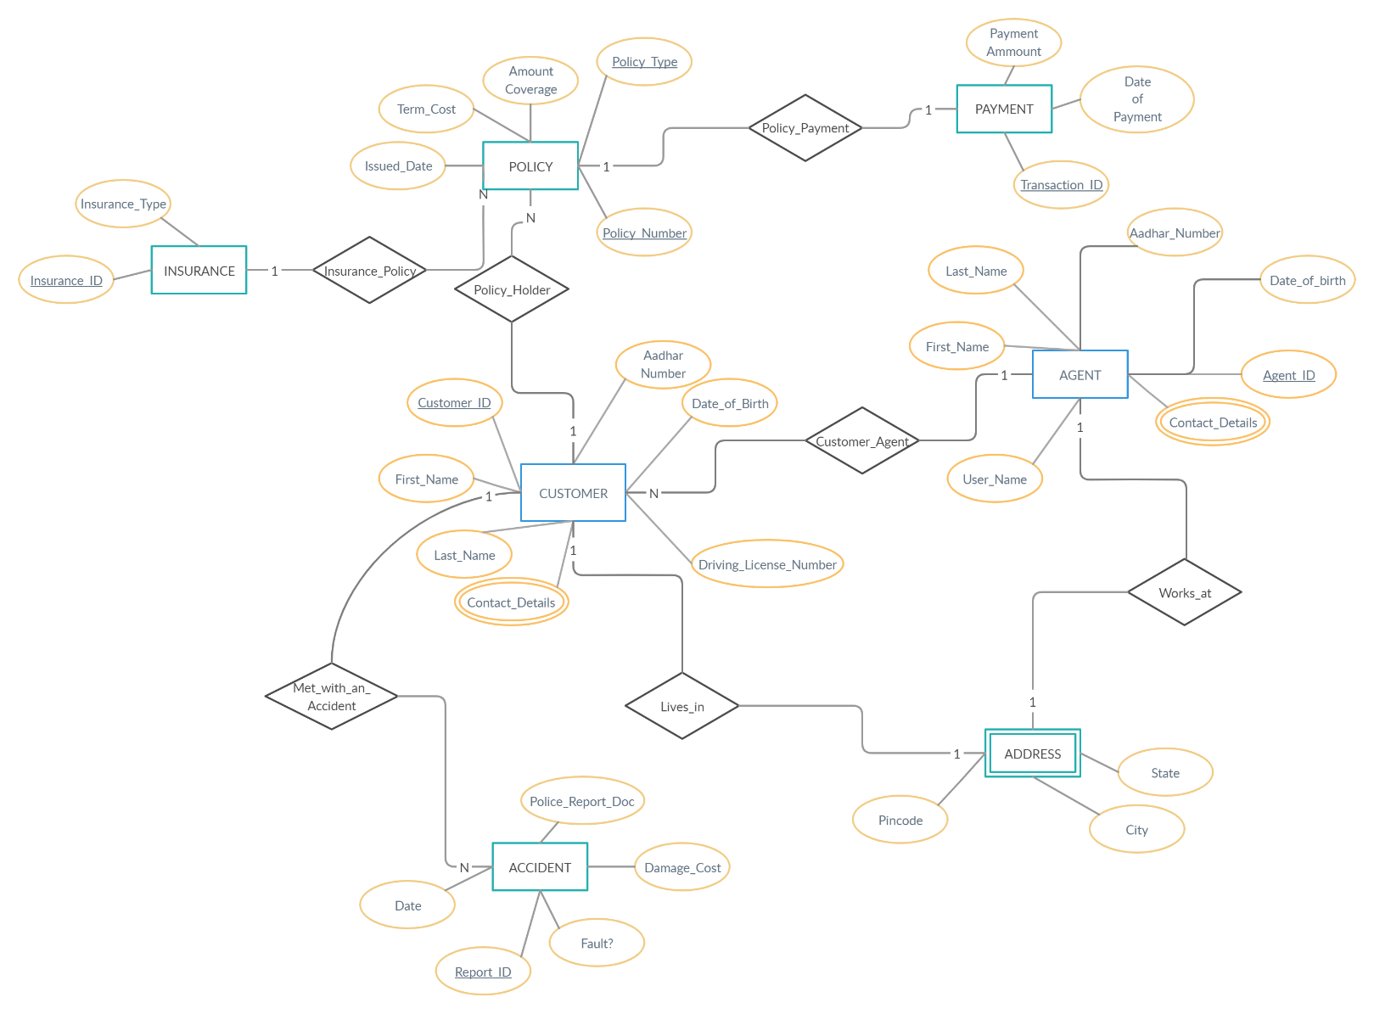

**Link:** <https://github.com/akshayjain3450/DBMSProject>